WT LAB test

Q2)

package WebTechJAVA.LAB.LabTest;

import java.util.Scanner;

public class BankAccount {

*int* acc_no;

    String name;

*double* balance;

    private Scanner scanner = new Scanner(System.in);

    BankAccount() {

        System.out.print("Enter the account number:\t");

        acc_no = scanner.nextInt();

        System.out.print("Enter the name of the account holder:\t");

        scanner.nextLine();

        name = scanner.nextLine();

        System.out.print("Enter the balance:\t");

        balance = scanner.nextDouble();

    }

    public static *void* displayBankAccountDetails(BankAccount *ba*) {

        System.out.println("Name:- " + *ba*.name);

        System.out.println("Account Number:- " + *ba*.acc_no);

        System.out.println("Balance :- " + *ba*.balance);

    }

    public static *void* checkForMoreBalance(BankAccount *ba1*, BankAccount *ba2*) {

        if (*ba1*.balance > *ba2*.balance) {

            System.out.println(*ba1*.name + " Has more Balance in his/her Account");

        } else {

            System.out.println(*ba2*.name + " Has more Balance in his/her Account");

        }

    }

    public static *void* main(String *args*[]) {

        System.out.println("For The 1st Person :");

        BankAccount bankAccount1 = new BankAccount();

        System.out.println("For The 2nd Person :");

        BankAccount bankAccount2 = new BankAccount();

        System.out.println("For The 1st Person :");

        displayBankAccountDetails(bankAccount1);

        System.out.println("-------------------------------------");

        System.out.println("For The 2nd Person :");

        displayBankAccountDetails(bankAccount2);

        checkForMoreBalance(bankAccount1, bankAccount2);

    }

}

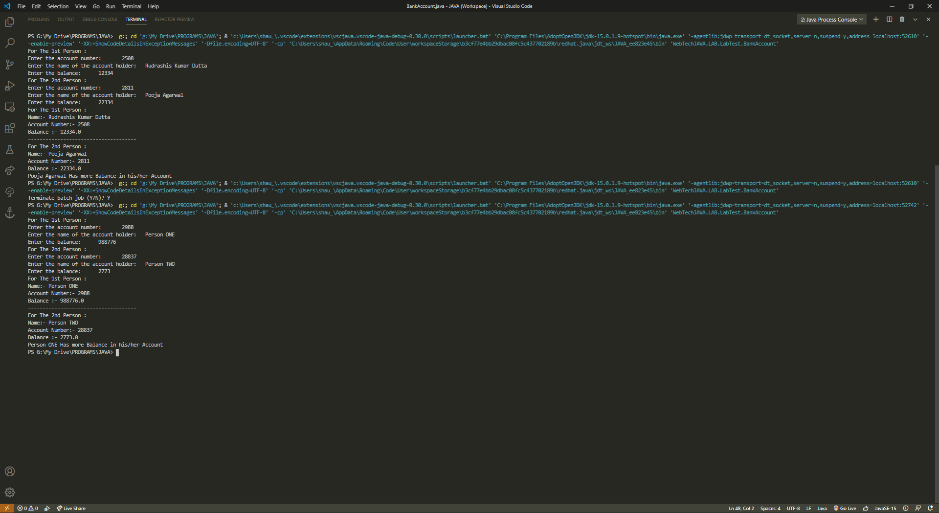

Main.html

<!DOCTYPE html>

<html>

<head>

    <title></title>

</head>

   <frameset rows="20%,80%">

<frame name="top" src="logo.html" >

  <frameset cols="20%, 80%">

    <frame src="Home.html" >

    <frame name="top" src="Registration.html" >

     <frame name="top" src="login.html" >

 <frame name="top" src="cart.html" >

  </frameset>

</frameset>

</html>

LOGO.html

<html lang="en">

<head>

<meta charset="UTF-8">

<meta name ="viewport"content ="width=device-width,initial-scale=1.0">

<title>DOCUMENT</title>

<style>

    img{

*height* : 50px;

*width* : 70px;

    }

    .container{

*display* : flex;

        padding_left : 1000px;

    }

    h1{

        padding_left:300px;

        colour : rebeccapurple;

    }

</style>

</head>

<body>

<div class = "container">

<img src="shop.png" alt= " "><h1><center>Online Shopping Center</center></h1>

<div>

</body>

</html>

HOME.html

<!DOCTYPE html>

<html><head><meta http-equiv="Content-Type" content="text/html; charset=windows-1252">

<style>

table, th, td {

*border*: 1px solid black;

*border-collapse*: collapse;

}

th, td {

*padding*: 15px;

*color*: red;

}

p{

*padding*:5px;

*font-size*:20px;

*font-weight*: bold;

}

</style>

</head>

<body>

<table style="width:100%">

  <tbody><tr>

    <th>Home</th>

  </tr>

  </tbody></table>

  <ul>

      <p>Mobile</p>

      <p>Electronics</p>

      <p>Computers</p>

      <p>Home Appliances</p>

      <p>Books</p>

      <p>Fashion</p>

  </ul>

</body>

</html>

Registration.html

Registration html file:-

<!DOCTYPE html>

<html>

<head>

    <style>

        table,

        th,

        td {

*border*: 1px solid black;

*border-collapse*: collapse;

        }

        th,

        td {

*padding*: 15px;

*color*: red;

        }

        .container {

*display*: flex;

*flex-direction*: row;

*padding*: 10px 20px;

*margin-left*: 300px;

*margin-top*: 150px;

        }

        .button{

*margin-left*: 400px;

        }

        .form{

*margin-left*:300px;

*margin-top*: 50px;

        }

    </style>

</head>

<body>

    <table style="width:100%">

        <tr>

            <th>Login</th>

            <th>Registration</th>

            <th>Help Center</th>

            <th>Cart</th>

        </tr>

    </table>

    <div class="form">

    <h2>Registration Page</h2>

    <form action="/action_page.php">

      <label for="fname">Name:</label><br>

      <input type="text" id="fname" name="fname" value="Rudrashis"><br><br>

      <label for="lname">password</label><br>

      <input type="password" id="lname" name="lname" value="password"><br><br>

      <label for="fname">E-mail id</label><br>

      <input type="text" id="fname" name="fname" value="1906354@kiit.ac.in"><br><br>

      <label for="fname">Phone number</label><br>

      <input type="text" id="fname" name="fname" value="8917544771"><br><br>

      <h3>Gender</h3>

        <input type="radio" id="male" name="gender" value="male">

      <label for="male">Male</label><br>

      <input type="radio" id="female" name="gender" value="female">

      <label for="female">Female</label><br>

      <input type="radio" id="other" name="gender" value="other">

      <label for="other">Other</label><br><br>

      <h3><label for="birthday">Date of birth:</label></h3>

      <input type="date" id="birthday" name="birthday"><br><br>

      <h3>Languages Known</h3>

      <input type="checkbox" id="vehicle1" name="vehicle1" value="Bike">

      <label for="vehicle1"> English</label><br>

      <input type="checkbox" id="vehicle2" name="vehicle2" value="Car">

      <label for="vehicle2"> Hindi</label><br>

      <input type="checkbox" id="vehicle3" name="vehicle3" value="Boat">

      <label for="vehicle3"> Odiya</label><br><br>

      <input type="checkbox" id="vehicle4" name="vehicle4" value="Bear">

      <label for="vehicle4"> Tamil</label><br><br>

      <input type="checkbox" id="vehicle5" name="vehicle5" value="Goat">

      <label for="vehicle5"> Bangla</label><br><br>

      <h3>Address</h3>

      <textarea name="message" rows="10" cols="30">

    Type Your address here

    </textarea><br><br>

      <input type="submit" value="Submit">

    </form>

</div>

</body>

</html>